Organizational Structure:

Executive Committee: Provides primary
oversight, completes grant planning & management, oversees budget.

Steering Committee: A team of consumers, advocates, family members, and providers which provides direction to the Executive Committee for budgeting expenditures, planning & development of programs to serve adults with SPMI/SMI.

Housing Committee: Promotes education, cooperation and coordination of housing services for adults with SMI & SPMI in order for them to fully participate in their recovery.

Education Committee: Presents twice yearly conferences for consumers, professionals and the general public on adult mental health topics.

- Please contact your County if interested in participating in BCOW Committees.

This information will be made available in alternate format upon request.

INPATIENT HOSPITAL-Short term hospital stays during a crisis.
- (701) 476-7200 Prairie St. John’s
- (701) 234-2000 Sanford Health
- (218) 847-5611 St. Mary’s Hospital

OUTPATIENT SERVICES-Non crisis mental health services that can be provided in the home or community.
- Lakeland Mental Health Center
- (218) 847-1676 Detroit Lakes
- (218) 233-7524 Moorhead
- (218) 736-6987 Fergus Falls
- (218) 346-5909 Perham
- Solutions Behavioral Healthcare Professionals
- (218) 287-4338 Moorhead
- (218) 844-6853 Detroit Lakes
- (218) 998-2992 Fergus Falls

ADDITIONAL RESOURCES-
- (800) 450-0459 Freedom Resource Center
- (218) 443-5286 NAMI – Moorhead
- (218) 736-1895 Ombudsman for MH/DD Consumers
- (651) 487-4987 Northstar Behavioral Health IRTS
- 1 (888) 458-1385 Mahube-Otwa
- (218) 512-1500 Lakes & Prairies Community Action (CAPLP)

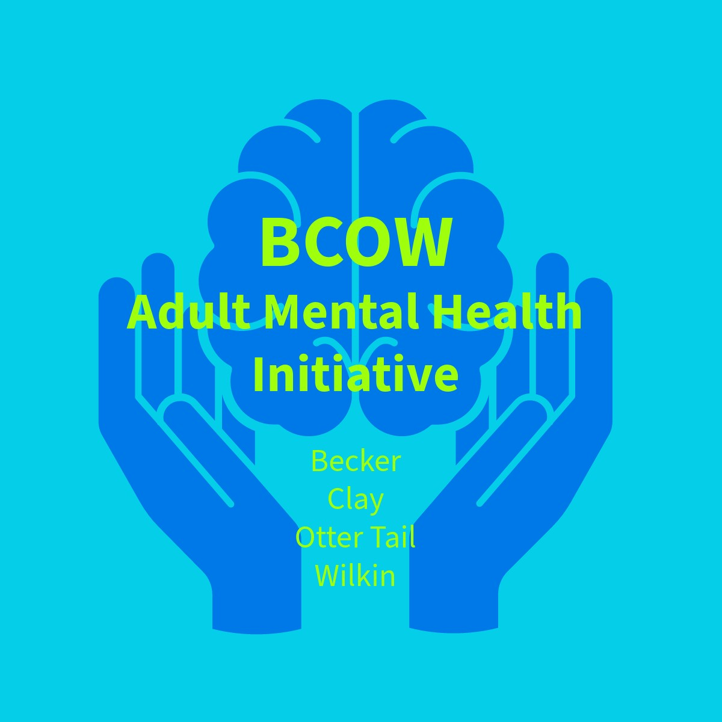

Becker County
218-847-5628

Clay County
218-299-5200

Otter Tail County
218-998-8150

Wilkin County
218-643-7161

The BCOW Adult Mental Health Initiative was established in 1995 with the following mission:
“To develop, support, promote and participate in a comprehensive community mental health system,
that will bring together the necessary programs and services to assist individuals and families in their
management of mental illness and recovery.”
Consumers, family members and service providers play a major leadership role in this development. Programs are developed to serve people with Serious Mental Illness (SMI) or Serious & Persistent Mental Illness (SPMI).

PROGRAM/SERVICES:
BCOW RENTAL ASSISTANCE– A temporary rental assistance program to bridge the gap between application & availability of Section 8 housing assistance. Available in all four counties.
- HRA- (218) 233-8883 Option 2
- Preapplication form can be found online at
www.claycohra.com

SUPPORTED HOUSING – A variety of supportive and subsidized settings are available in all four counties.
- (218) 846-7316 HRA - Becker County
- (218) 233-8883 HRA – Clay County
- (218) 847-7859 HRA- Detroit Lakes
- (218) 739-3249 HRA – Otter Tail County
- (218) 643-6147 HRA –Breckenridge
- (218) 739-3249 --- Garitz Grove

TRANSITIONAL HOUSING- Temporary housing that helps support individuals move from homelessness to permanent housing.
- (218) 205-0545 Matthew House
- Barbara House
- (218) 298-0083 Perham 180
- BCOW Transitional Apartments

FLEXIBLE FUNDING – Funds used to pay for medications, housing deposits/rent, furniture, transportation, supplies, utilities, clothing for work and other determined needs when no other funding is available.

CRISIS SERVICES- Crisis response services offered to de-escalate situations in the least restrictive setting & develop strategies to address any future safety concerns.
Provides telephone or face-to-face crisis intervention services to adults and children/families who need assistance and who are at risk of inpatient psychiatric hospitalization. Provides crisis beds for those persons who are at risk of psychiatric hospitalization, yet don’t meet hospital level of care. Services located in Fergus Falls & Detroit Lakes.
- (218) 850-HELP Becker Co./White Earth Mobile Crisis
- (800) 223-4512 Clay, Otter Tail & Wilkin Mobile Mental Health
- (218) 998-2525 PAI Crisis Stabilization Unit -Fergus Falls
- (218) 844-1733 Willow Tree Crisis Stabilization - Detroit Lakes
- (218) 233-8068 Gull Harbor Crisis Beds-Moorhead

AFTERCARE – Consumers discharged from inpatient hospitals or IRTS facilities who are at risk of hospitalization may receive intensive contacts from an outreach worker.
- (218) 236-6730 CCRI
- (218) 736-6987 Lakeland Mental Health Center
- (218) 847-5628 Becker County Human Services

RECOVERY CLUBS –The clubs provide social, recreational and educational activities in an informal setting. The clubs help prevent social isolation, provide support, promote recovery and prevent relapse.
- A Place for Friends-Wilkin County-
(218) 517-0623
- A Place To Belong-Becker County
(218) 846-9022
- A Place To Belong-Otter Tail County
(218) 739-0894
- A Place For Hope-Clay County
(218) 284-6069

EMPLOYMENT – Provides supported employment services in all four Counties with the goal of placement for persons with SMI or SPMI in to competitive wage jobs using the Individual Placement & Support
(IPS) model of services.
- (701) 388-4865 Transem
Additional Employment Services:
- (218) 998-5630 Productive Alternatives, Inc.
- (218) 350-1210 Vocational Rehabilitation Service

INTENSIVE RESIDENTIAL TREATMENT SERVICES – (IRTS) Provides short-term intensive residential treatment for persons who are being discharged or recently discharged from inpatient hospitalization or who are at risk of inpatient treatment. BCOW can provide funding for individuals without another payor source.
- (218) 233-8068 Gull Harbour IRTS

PROGRAMS/SERVICES PROVIDED WITHIN BCOW NOT FUNDED BY AMHI GRANT:

CERTIFIED PEER SPECIALIST (CPS)- individuals who have had personal experience of mental illness and are trained to be direct service mental health staff.
- (800) 862-1799 Mental Health Minnesota
- (844) 843-9489 Wellness in the Woods

ADULT LOCAL ADVISORY COUNCILS (LAC’s)- Coordination of information sharing, needs assessment and service planning with all four BCOW counties.

COMMUNITY BEHAVIORAL HEALTH HOSPITAL-Short term acute psychiatric hospital.
- (218) 332-5001 CBHH – Fergus Falls

